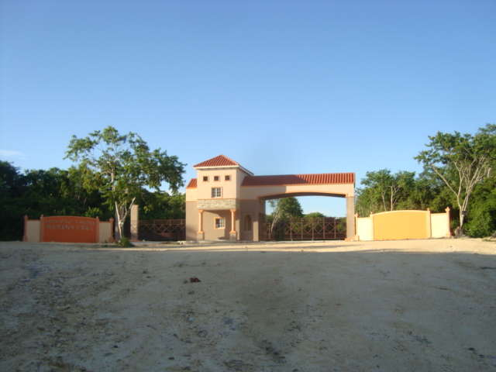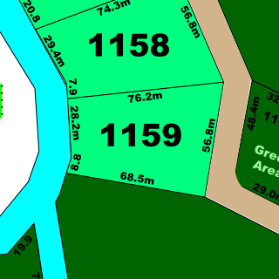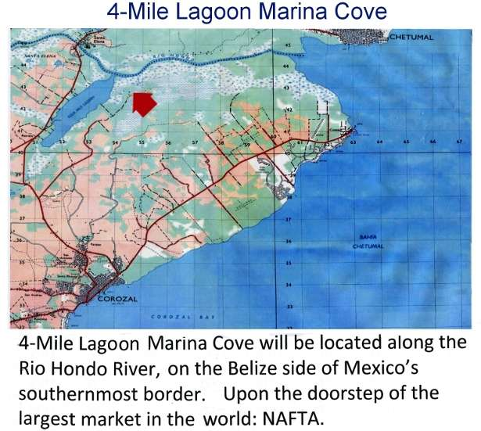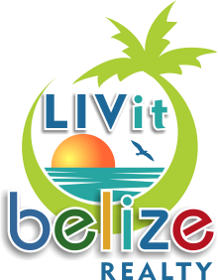

Four Mile Lagoon Marina Cove

***Paradise Awaits***

LIVitBelize Realty · www.LIVitBelize.com · 501-523-4095

**MS-035**

**Contact Us : 1-800-479-4439 US/CAN**

**$80,000 USD**

Close access to Chetumal

Corozal Free Zone

Corozal District

.81 Acres

Close to Rio Hondo

**Lot**

Key Features: