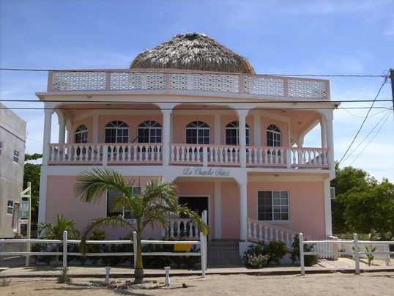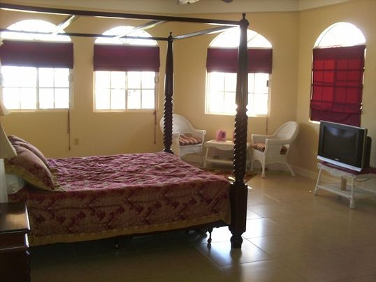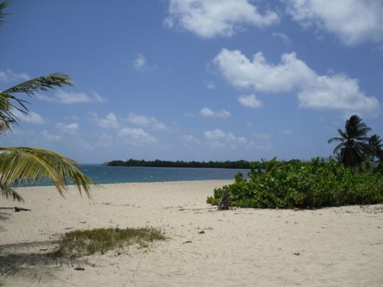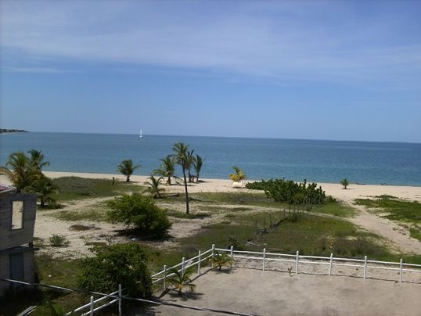

More short descriptive wordage

**Additional Features**: All of the appointed suites come complete with a flat screen HDTV, coffee maker, a refrigerator and air conditioning and ceiling fan. The guests also have exclusive usage of the stunning rooftop observation deck which offers a wonderful 360 degree view of the surrounding area including the Caribbean Sea, Maya Mountains, and lagoon.

City/Town/Village: Placencia District: Stann Creek District Country: Belize

*Please call to arrange a private viewing*

*Toll Free* 1-800-855-543-5432*Local* +501-523-4095

*Email* info@livitbelize.com

**Property Name**

*Placencia, Belize*

***US $Price***

Property Type

Type in Property Description information here……..